**Name 1:李璇SID 1:12010137 Name 2:张林燊SID 2:12010424**

实验报告#4 (Lab#4)

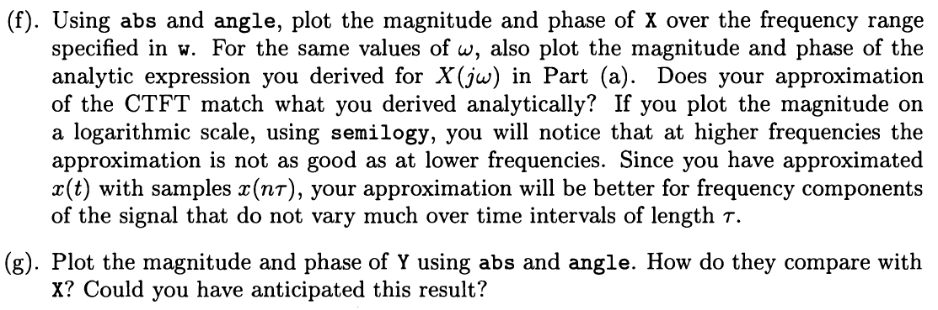**4.2**

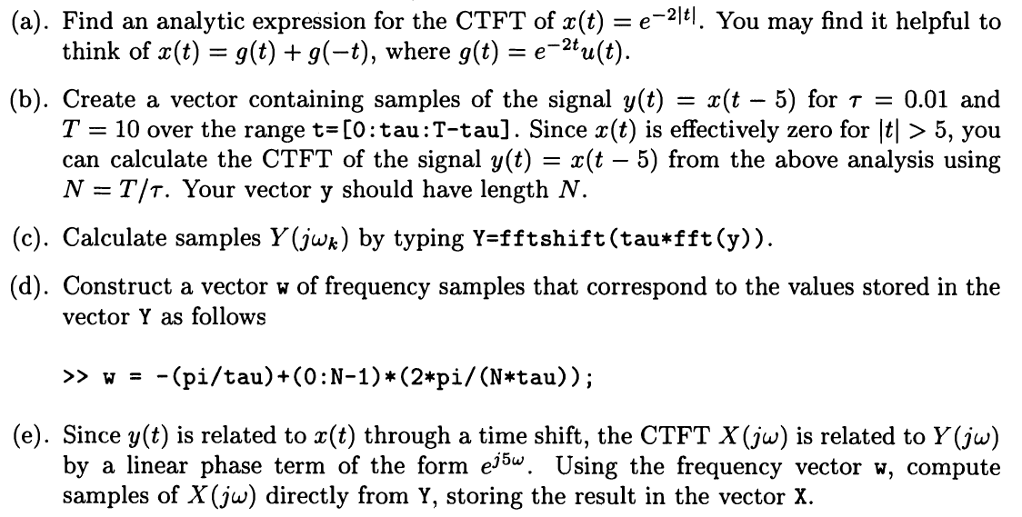

**Solution:**

1. From the BASIC FOURIER TRANSFORM PAIRS TABLE, we know that G(jω) = 1/(2+jω). So X(jω) = G(jω) + G(-jω) = 1/(2+jω) + 1/(2-jω).

**(b)~(e) can be seen in the attached code.**

**(f)**

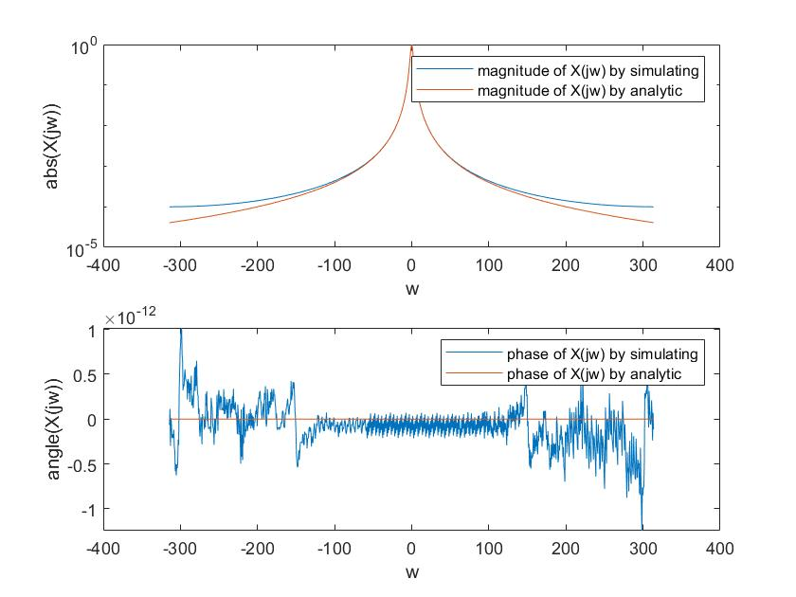

We use logarithmic scale to plot the figure of magnitude of X, and normal scale to plot the figure of phase of X.

**(g)**

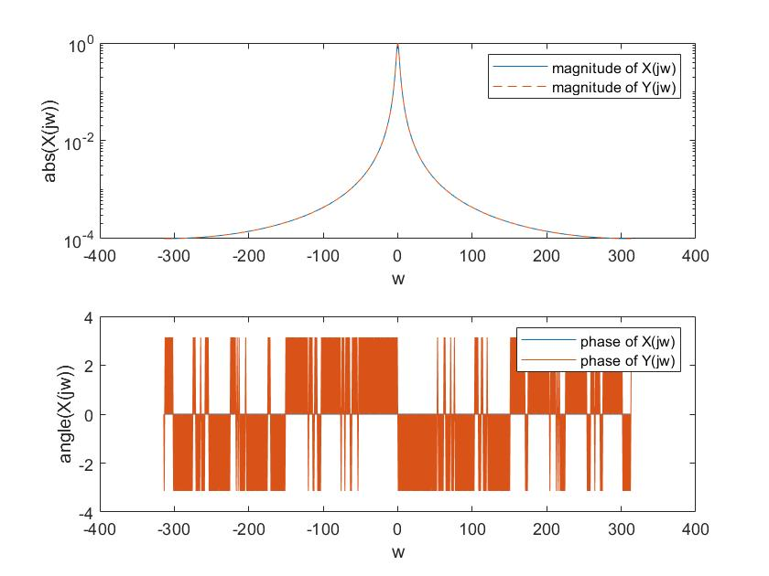

It could be noticed that the magnitude of Y(jw) equals to that of X(jw) and the phase has a difference of e5jw.

**Matlab code:**

tau=0.01;

T=10;

N=T/tau;

t=0:tau:T-tau;

x=exp(-2*abs(t));

y=exp(-2*abs(t-5));

a=(1/N).*fft(y);

Y=fftshift(tau*fft(y));

w=-(pi/tau)+(0:N-1)*(2*pi/(N*tau));

X=exp(5*1j*w).*Y;

X_=(1./(2+1j*w))+(1./(2-1j*w));

figure(1);

subplot(2,1,1);

semilogy(w,abs(X));

hold on;

semilogy(w,abs(X_));

xlabel('w');

ylabel('abs(X(jw))');

legend('magnitude of X(jw) by simulating','magnitude of X(jw) by analytic');

subplot(2,1,2);

plot(w, angle(X));

hold on;

plot(w,angle(X_));

xlabel('w');

ylabel('angle(X(jw))');

legend('phase of X(jw) by simulating','phase of X(jw) by analytic');

figure(2);

subplot(2,1,1);

semilogy(w,abs(X));

hold on;

semilogy(w,abs(Y),'--');

xlabel('w');

ylabel('abs(X(jw))');

legend('magnitude of X(jw)','magnitude of Y(jw)');

subplot(2,1,2);

plot(w, angle(X));

hold on;

plot(w,angle(Y));

xlabel('w');

ylabel('angle(X(jw))');

legend('phase of X(jw)','phase of Y(jw)');

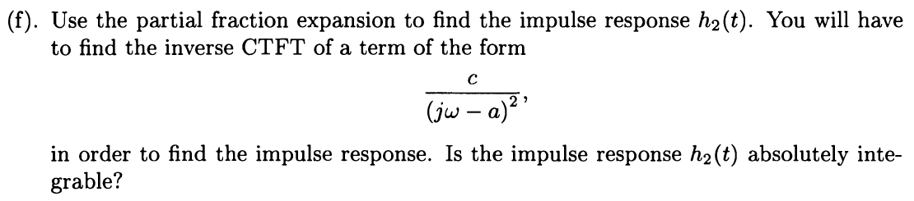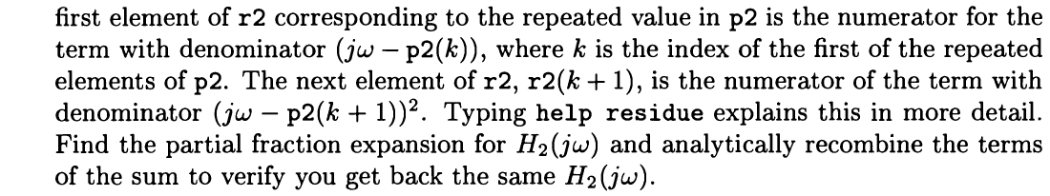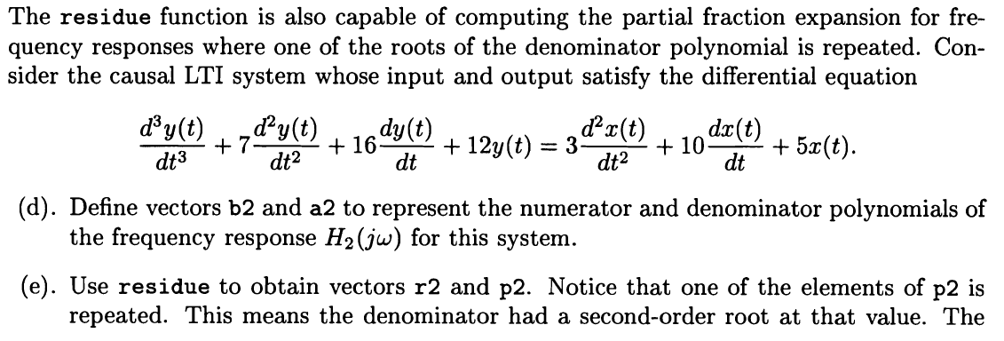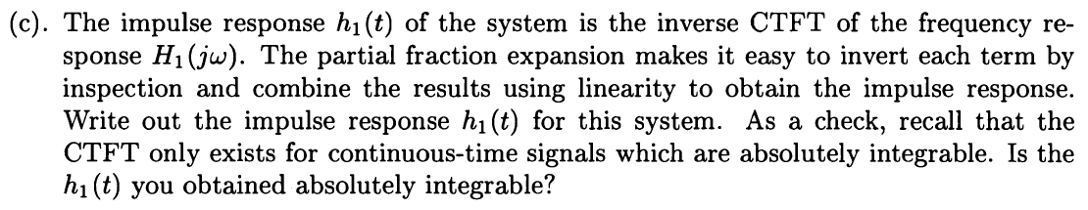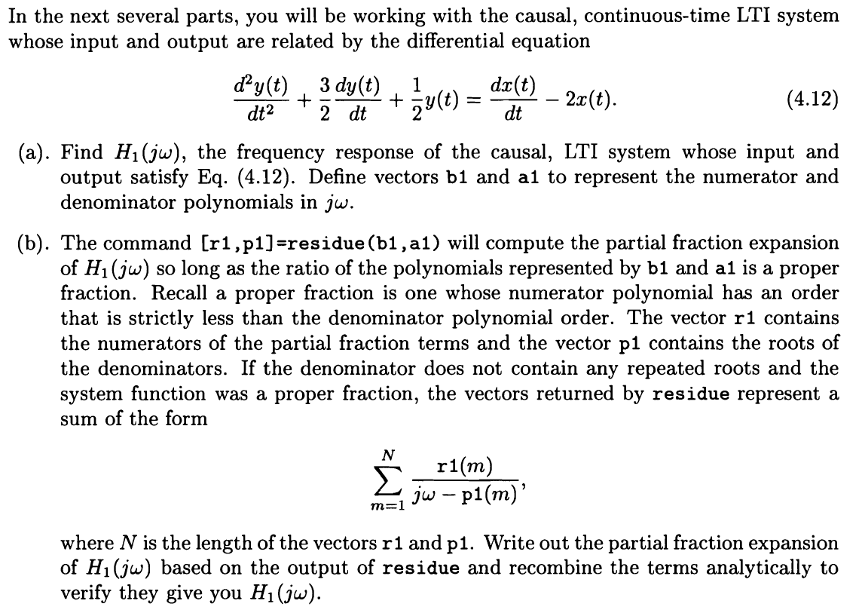**4.5**

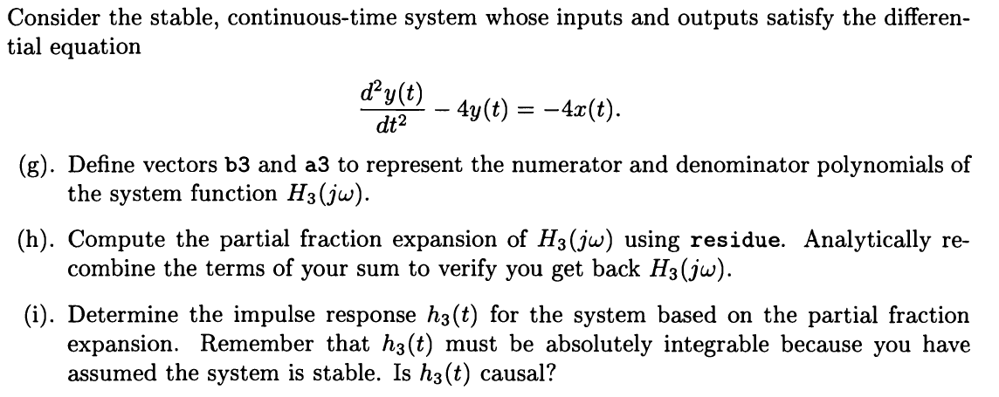

**Solution:**

1. We have a­­­1=[1 3/2 1/2] and b1=[1 -2], so H1(jw)=.
2. From the matlab code: [r1 p1]=residue(b1,a1); we get r1 and p1 as follows.

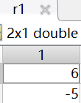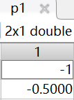

So H1(jw)=+=.

1. h1(t)=6e-tu(t)-5e-1/2tu(t)

=4, thus h1(t)is integrable and H1 exists.

1. We have a2=[1 7 16 12] and b2=[3 10 5], thus H2(jw)=.
2. From the matlab code: [r2 p2]=residue(b2,a2); we get r2 and p2 as follows.

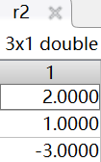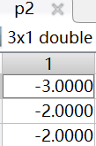

So H2(jw)=++ and it is equal to H2(jw)=. So the result is correct.

1. h2(t)=2e-3tu(t)+e-2tu(t)-3te-2tu(t).

=, thus h2(t)is absolutely integrable.

1. We have a3=[1 0 -4] and b3=[-4], thus H3=.
2. From the matlab code: [r3 p3]=residue(b3,a3); we get r3 and p3 as follows.

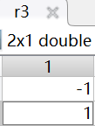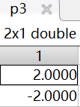

So H3(jw)=+=.

1. h3(t)=-e2tu(t)+e-2tu(t)

h3(t) is also absolutely integrable.

When t<0, h3(t)=0. Thus it is casual.

**4.6**

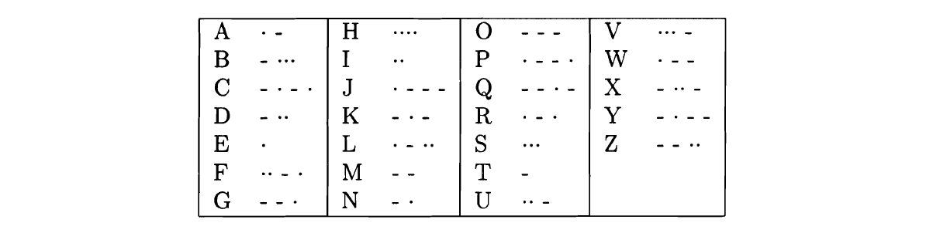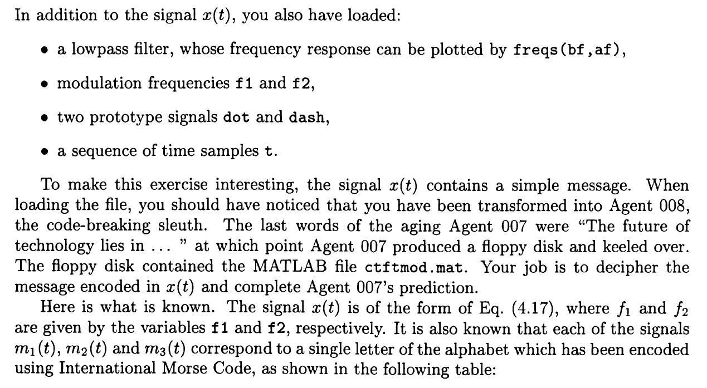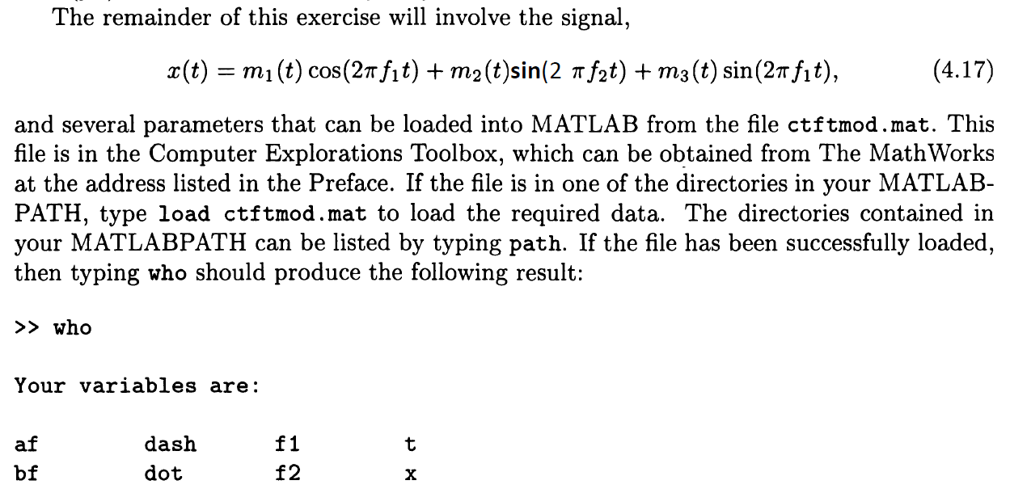

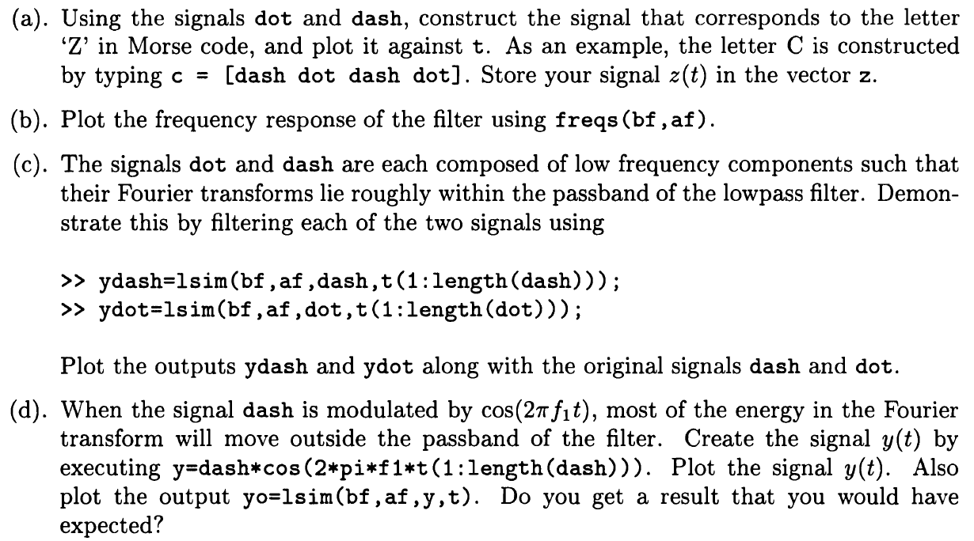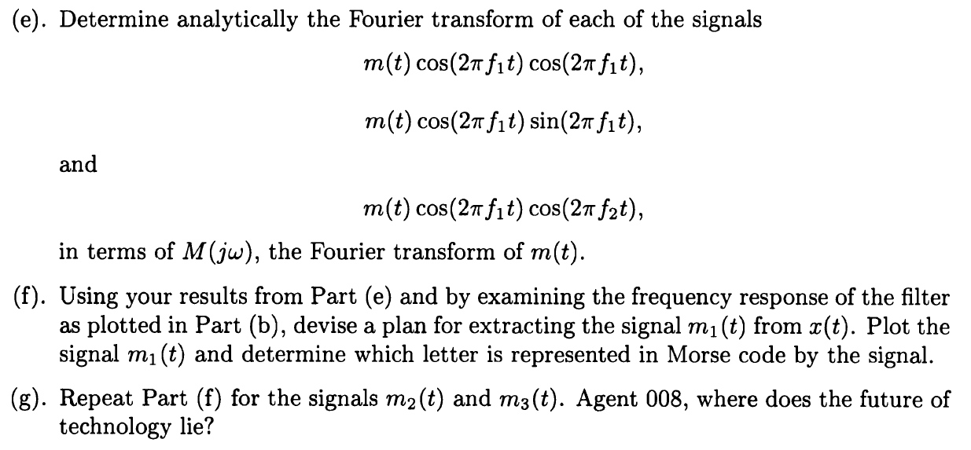

**Solution:**

**(a)**

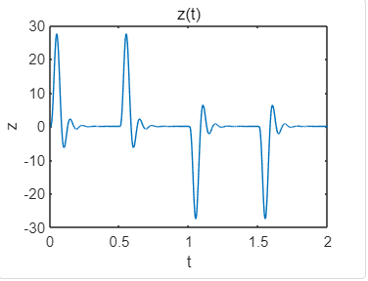

**Matlab code:**

%4.6(a)

z=[dash dash dot dot];

plot(t,z);

title('z(t)');

ylabel('z');

xlabel('t');

**(b)**

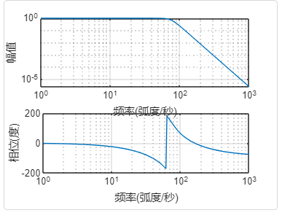

**Matlab code:**

%4.6(b)

freqs(bf,af);

**(c)**

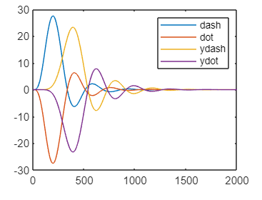

**Matlab code:**

%4.6(c)

ydash=lsim(bf,af,dash,t(1:length(dash)));

ydot=lsim(bf,af,dot,t(1:length(dot)));

plot(dash);

hold on;

plot(dot);

hold on;

plot(ydash);

hold on;

plot(ydot);

hold on;

legend('dash','dot','ydash','ydot')

**(d)**

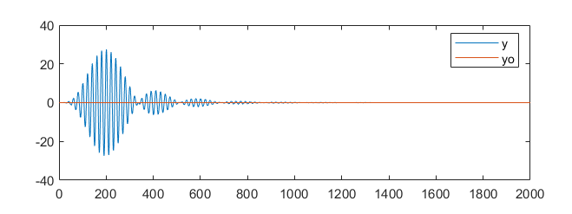

**Matlab code:**

%4.6(d)

y=dash.*cos(2*pi*f1*t(1:length(dash)));

yo=lsim(bf,af,y,t(1:length(y)));

plot(y);

hold on;

plot(yo);

legend('y','yo');

**(e)**

**(f)**

As can be seen from the graph, it represents D.

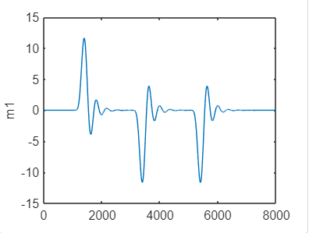

**Matlab code:**

y1=x.*cos(2*pi*f1*t(1:length(x)));

m1=lsim(bf,af,y1,t(1:length(y1)));

figure(1);

plot(m1);

ylabel('m1');

**(g)**

As can be seen from the graph, it represents S and P. The result is DSP.

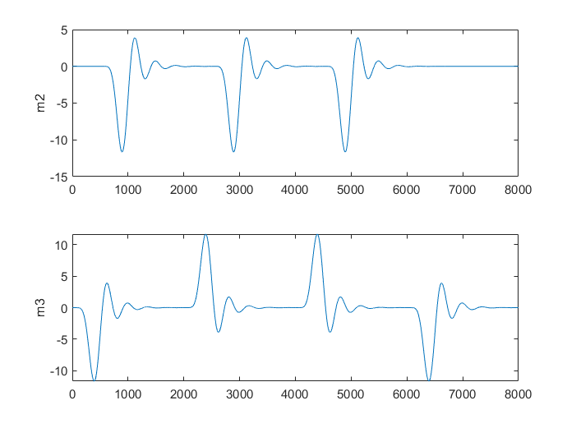

**Matlab code:**

y2=x.*sin(2*pi*f2*t(1:length(x)));

m2=lsim(bf,af,y2,t(1:length(y2)));

subplot(2,1,1);

plot(m2);

ylabel('m2');

y3=x.*sin(2*pi*f1*t(1:length(x)));

m3=lsim(bf,af,y3,t(1:length(y3)));

subplot(2,1,2);

plot(m3);

ylabel('m3');